**Lab 4 Activity 3 - Working with Themes**

**Objective** - Develop students' ability to create slides with varying layouts, format text, and adjust alignment to improve readability and visual hierarchy

1. Apply a built-in theme to your presentation from the Design tab. Explore and discuss the impact of themes on slide aesthetics and consistency.
2. Customize the theme by Changing the theme colors to align with a given topic (e.g., blue for technology, green for sustainability). Modifying theme fonts to suit the presentation tone (e.g., Serif fonts for formal topics, Sans Serif for modern or casual themes).
3. Apply different background styles (e.g., gradient, solid fill, picture) to individual slides and evaluate how they affect readability.
4. Save the presentation with the updated theme as a new file. Revert changes on specific slides to the default theme to learn theme management.

**____________________________________________________________________________________**

**Solutions:**

**Task 1:**

Themes play an important role to the viewer, allowing them to like or dislike the pattern of the presentations.

**Task 2:**

* Open powerpoint, select any theme.

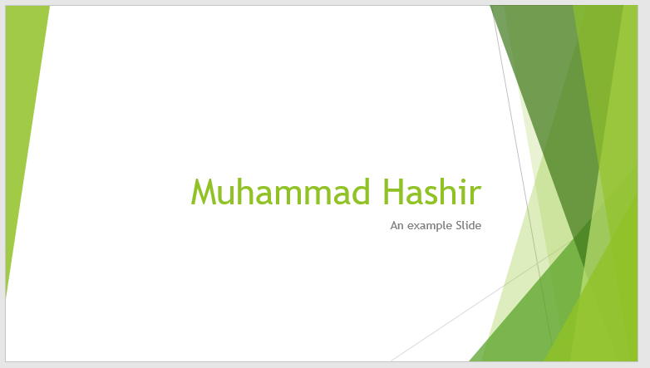

**Task 3:**



**Task 4:**

* Save the file
* And quit.